Welcome to The De Lacy Centre at Bradford Cathedral
Stott Hill, Bradford, BD1 4EH

The next CVF Members Meeting on Thursday 18 July will take place at Bradford Cathedral, in the De Lacy Centre 1:30 - 3:30pm. This visual story contains information on how to get to the De Lacy Centre at Bradford Cathedral by bus or car, and what to expect once you’re there.
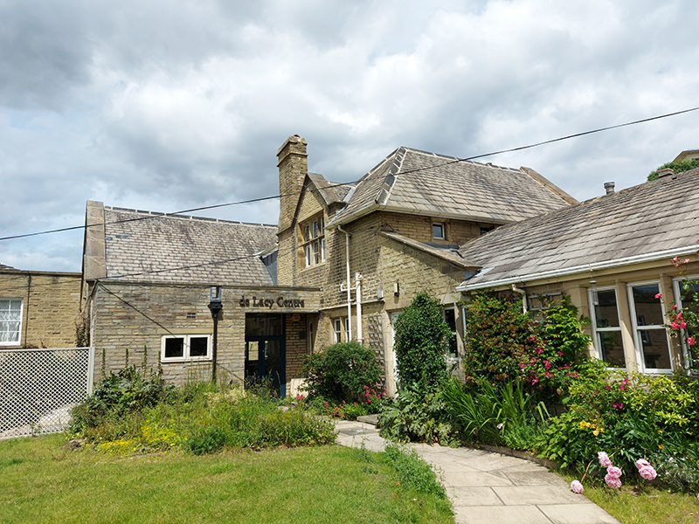
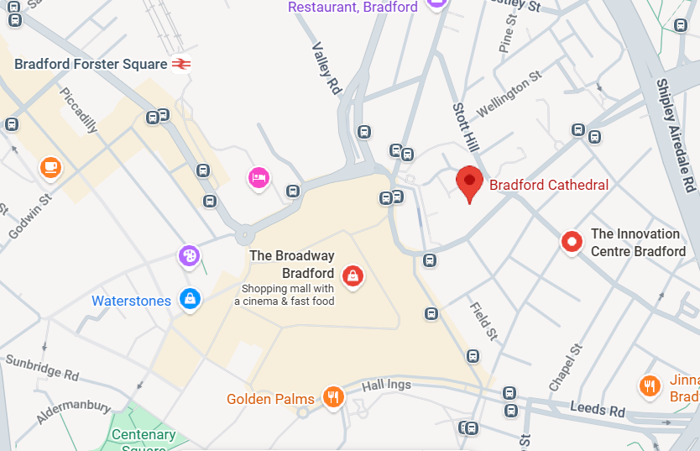

De Lacy Centre Entrance Map of Bradford Cathedrals location

Bradford Cathedral is on top of a hill and many of the paths around the building are steep. There are 3 entrances to Bradford Cathedral:

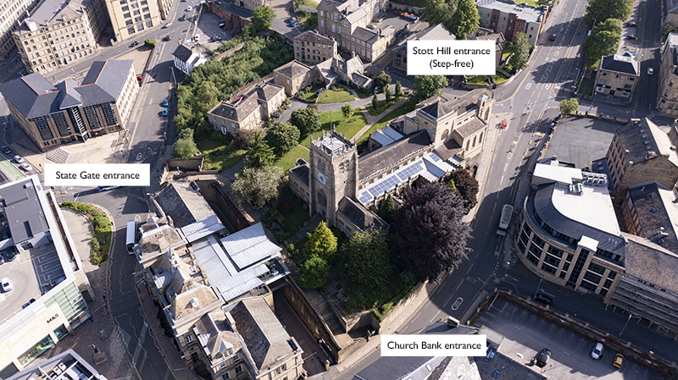

The Stott Hill Entrance is step free and most accessible.

Getting here by bus

Upper Park Gate on Barkerend Road is the closest bus stop to the step free entrance.
Buses: 642, 645, 660, 671, X11

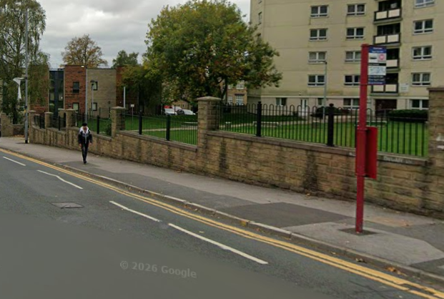
Follow Barkerend Road down towards the Cathedral on the corner of Stott Hill. This is a 2 minute walk.
Image of Upper Park Gate bus stop

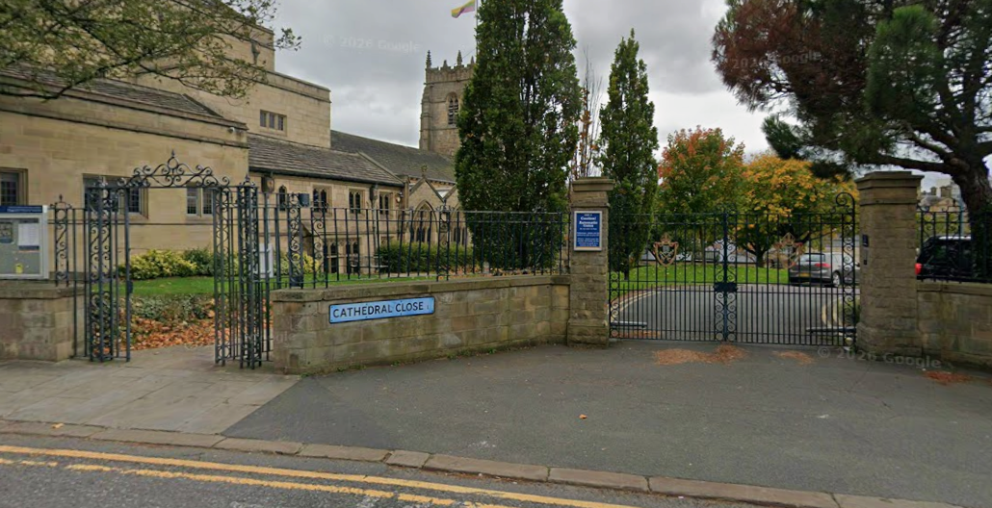

There is a gated entrance to the Cathedral, the smaller gate to the left will be open and you can enter through there.

The De Lacy Centre is on the right as you enter the gates.

Entrance to the cathedral via steps (state gate entrance) from Cathedral N bus stop. Buses: 622, 626, 633, 634, 635, 643, 644, 653, 662, 680, 820, 864, A2, A3
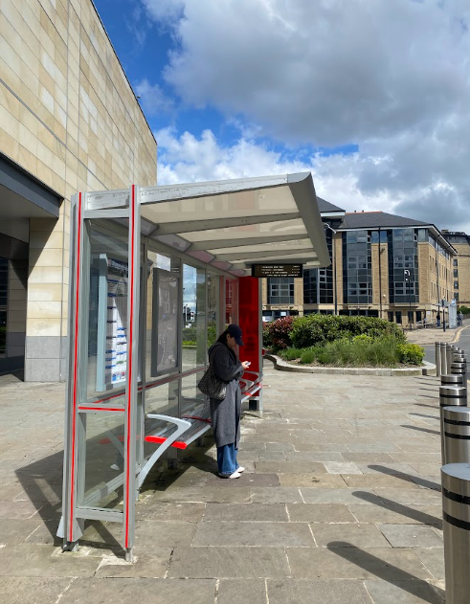
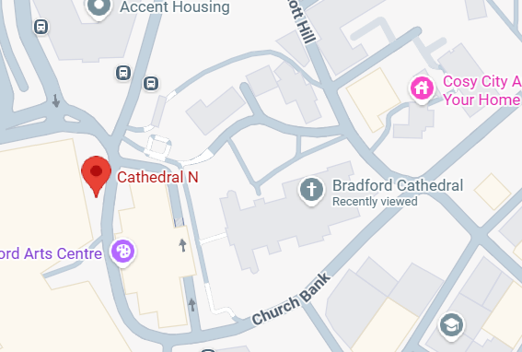
Map of Bus stop on Church Bank Image of bus stop

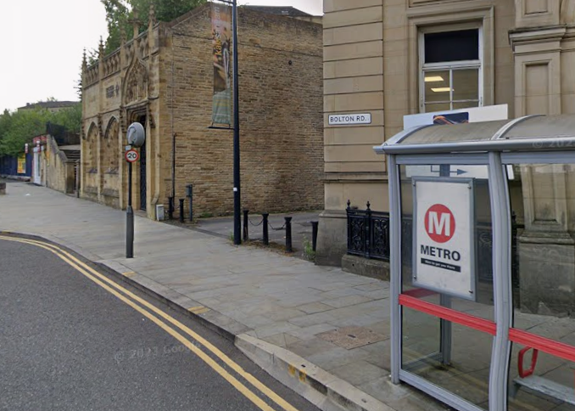

Image of bus stop on Church Bank
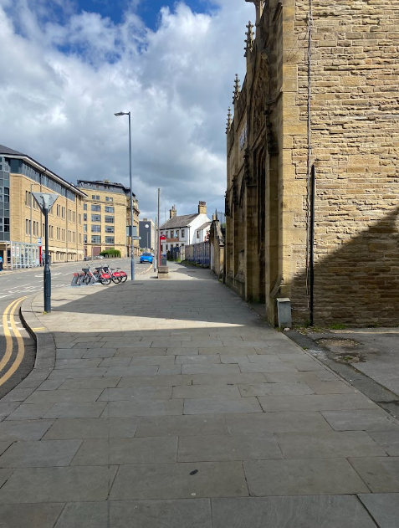

Go down Church Bank, towards on the same side of the street as Bradford Arts Centre

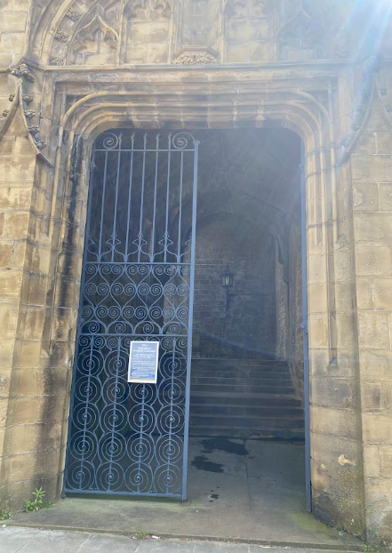
steps
Find the gated entrance and take the steps to Bradford Cathedral.

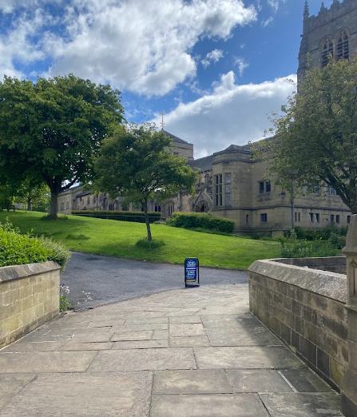

Once in the Cathedral grounds, take the path to the left to the De Lacy Centre

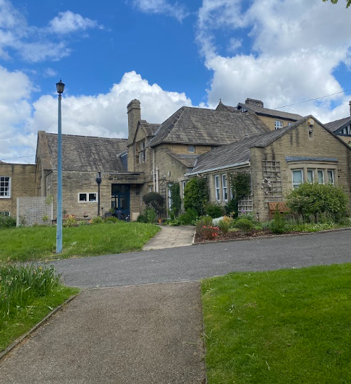

Image of De Lacy Centre
For drop off by car:

Cars are able to stop to drop off on Stott Hill, outside the blue gated entrance called Cathedral Close.

To be dropped off directly outside the De Lacy Centre, you can open the double gates for cars to drive through using the button on the right pillar
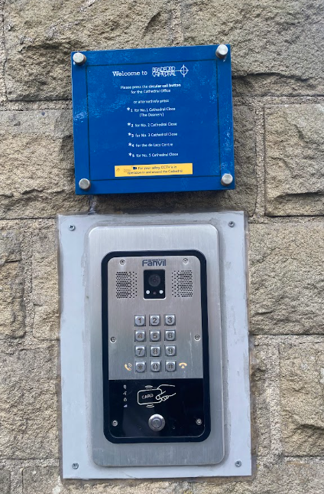
Follow the instructions on the blue sign, press 4 for the De Lacy Centre

The De Lacy Centre is directly on the right as you enter the gates.
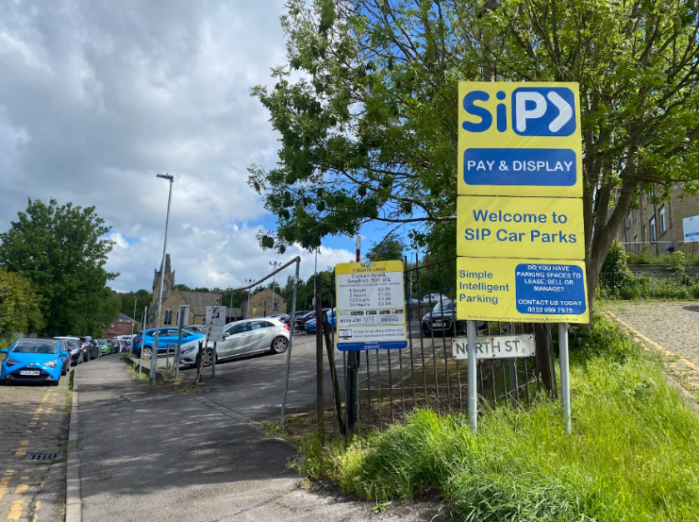
Getting here by car, parking:
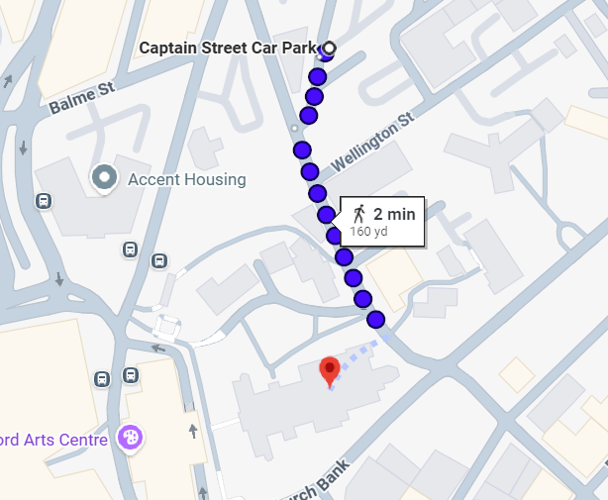
There is a car park on Captain Street, a 2-minute walk from the main cathedral entrance. Please note that this car park is also steep, there is some on street parking available outside the main cathedral entrance which is more level.

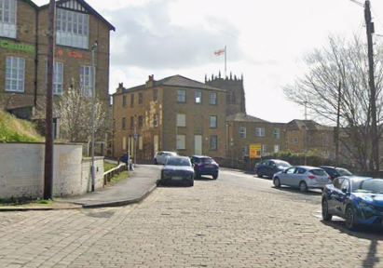
Exit the car park and follow Stott Hill towards the Jubilee Centre

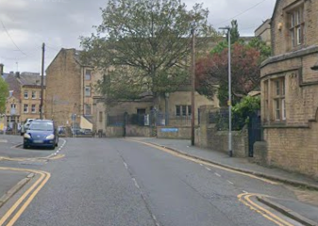
Keep following the road until you see Cathedral Close with the blue gates to the main entrance of the Cathedral.

When you arrive:

There is one main room where we will be gathering. Assistant animals and emotional support animals are welcome.

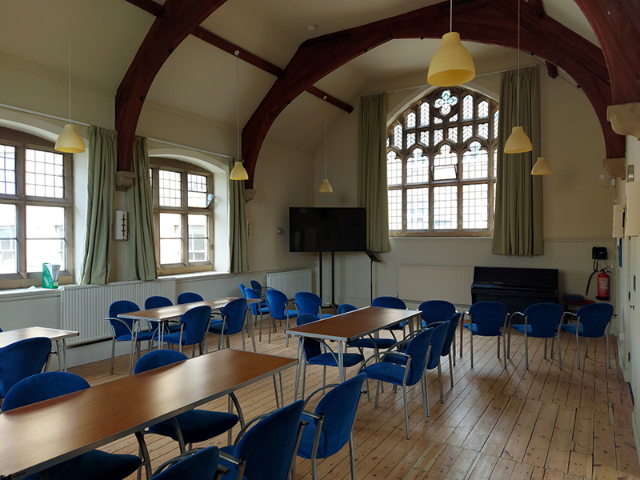

There is an accessible toilet with a baby change directly on the right as you enter the De Lacy Centre.

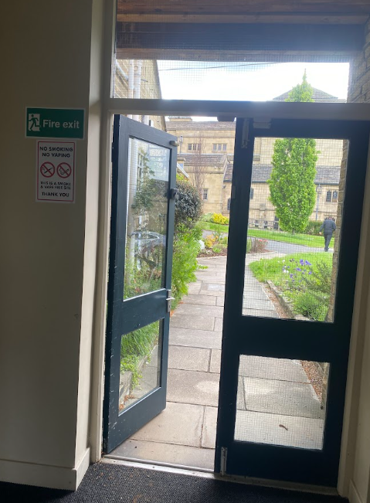
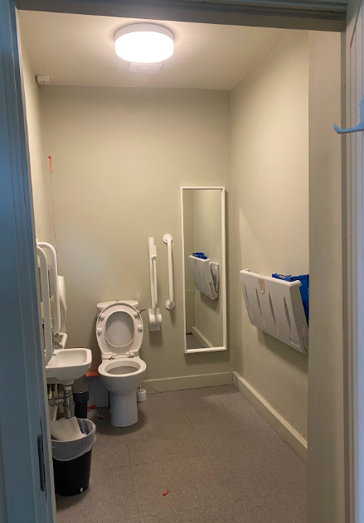

The main entrance to the De Lacy Centre is the closest fire exit.
There is an additional toilet towards the front of the main room on the right.

