Welcome to September 2026 CVF Members Meeting – Manningham Mills, Silk Hall

Manningham Mills Community Centre, Lilycroft Road, Bradford, BD9 5BD
This visual story contains information on how to get to the Skill Hall at Manningham Mills Community Centre by bus or car, and what to expect once you’re there.

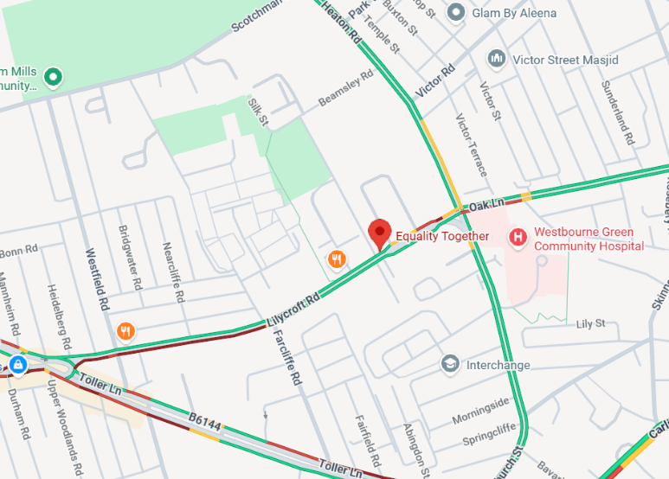
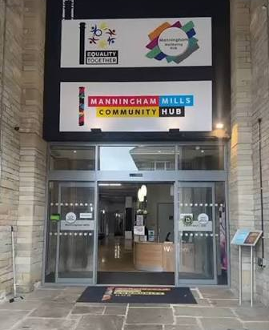
Map of Manningham Mills Community Centre (Lister Mills)

Manningham Mills Community Hub entrance

Getting here by bus
There are bus stops on Lilycroft road a short distance from Manningham Mills. Please be aware that Lilycroft road is a slight hill.
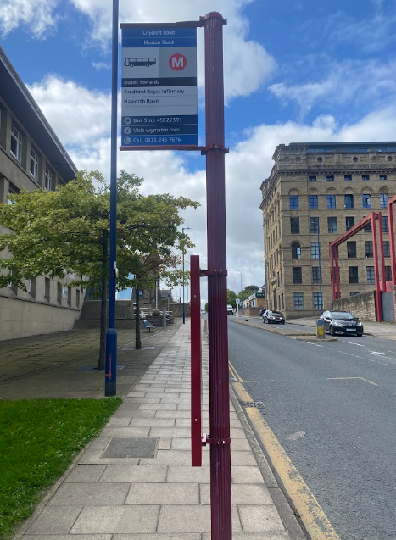

The closest bus stop is on the 620 route from Bradford City centre.

Once you have gotten off the bus you can see Lister Mills. There is a crossing you can use to cross the road.

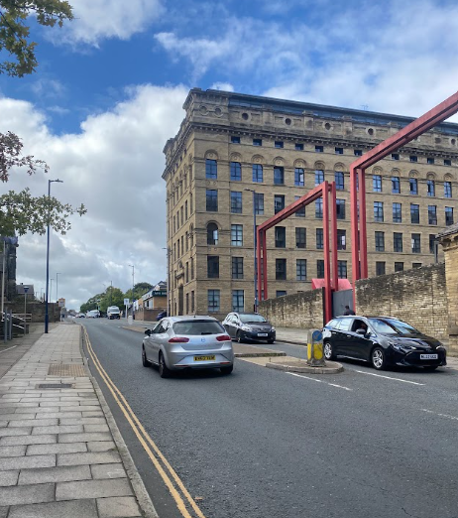

Cross the road and travel up the road, past the red beams. The entrance is at the front of Lister Mill on the right.

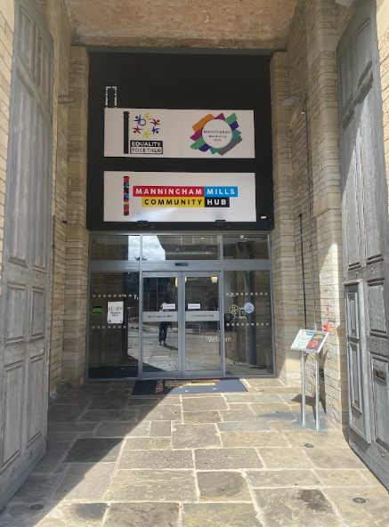
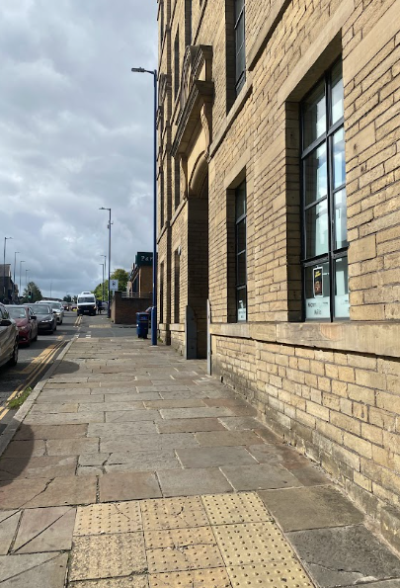

Follow the road upwards and find the entrance to Manningham Mills on the right.

Main entrance to Manningham Mills

Getting here by car:

Getting here by car:
There is street parking on Patent Street, 2 minutes around the corner to the entrance of Manningham Mills, which you can use for free. If all street parking spaces are taken there is also a car park on Patent Street, please be aware you have to pay to use the car park.

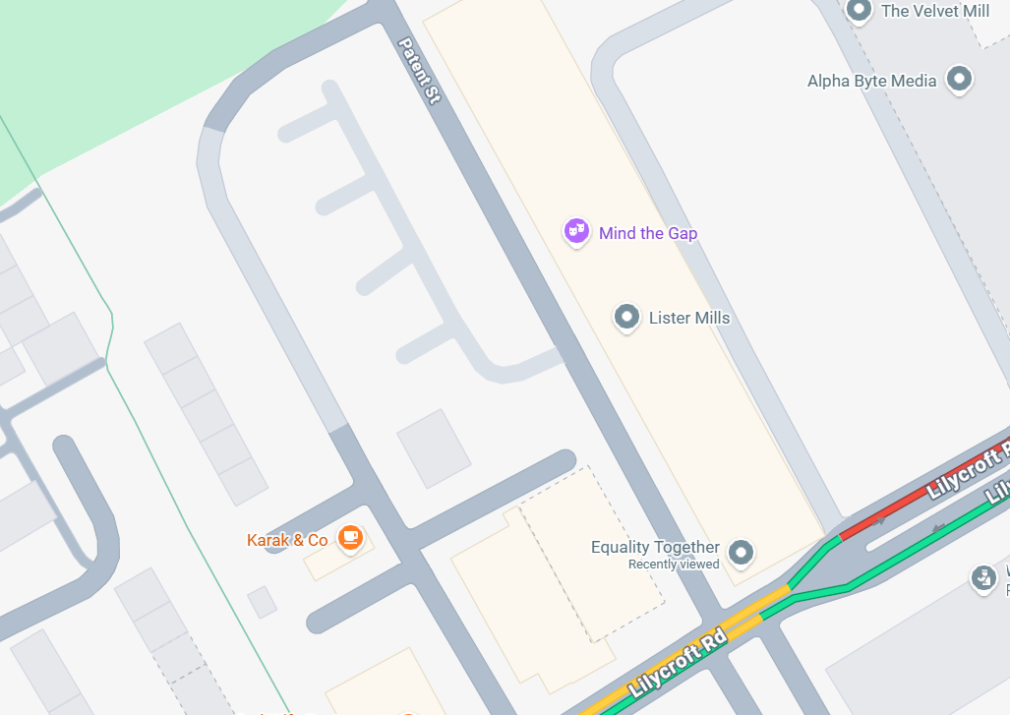
Car park on Patent Street

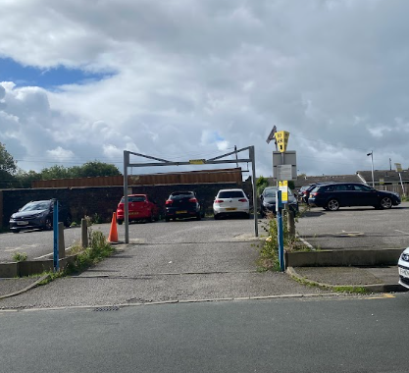
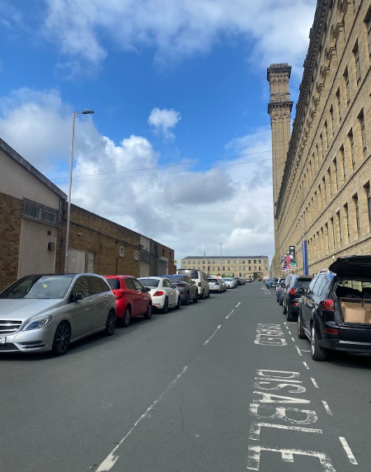
Entrance to car park.
View of Patent Street, follow road up, the car park is on the left.

Once you arrive:
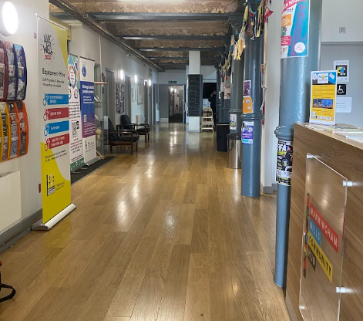
You will arrive at reception, continue forwards towards the café. Please note the toilets are on the right as you arrive past reception.
Toilets and accessible toilets.
Enter through the sliding doors.

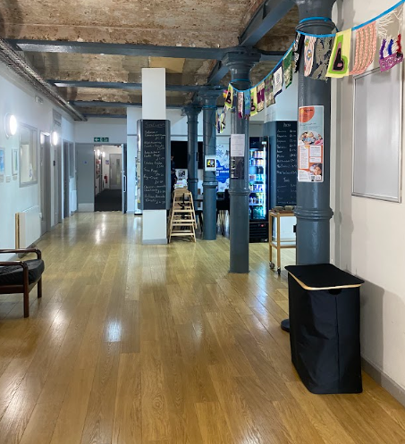

Go past the café and turn right at the column with the blackboard on it.

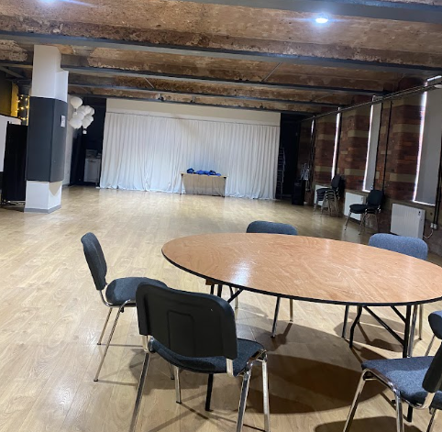
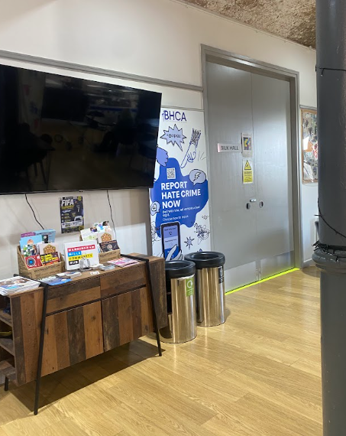
Image of Silk Hall
The entrance to the Silk Hall is through the grey double doors

